The Avenues – Cheltenham Annual Sports and Cultural Exchange
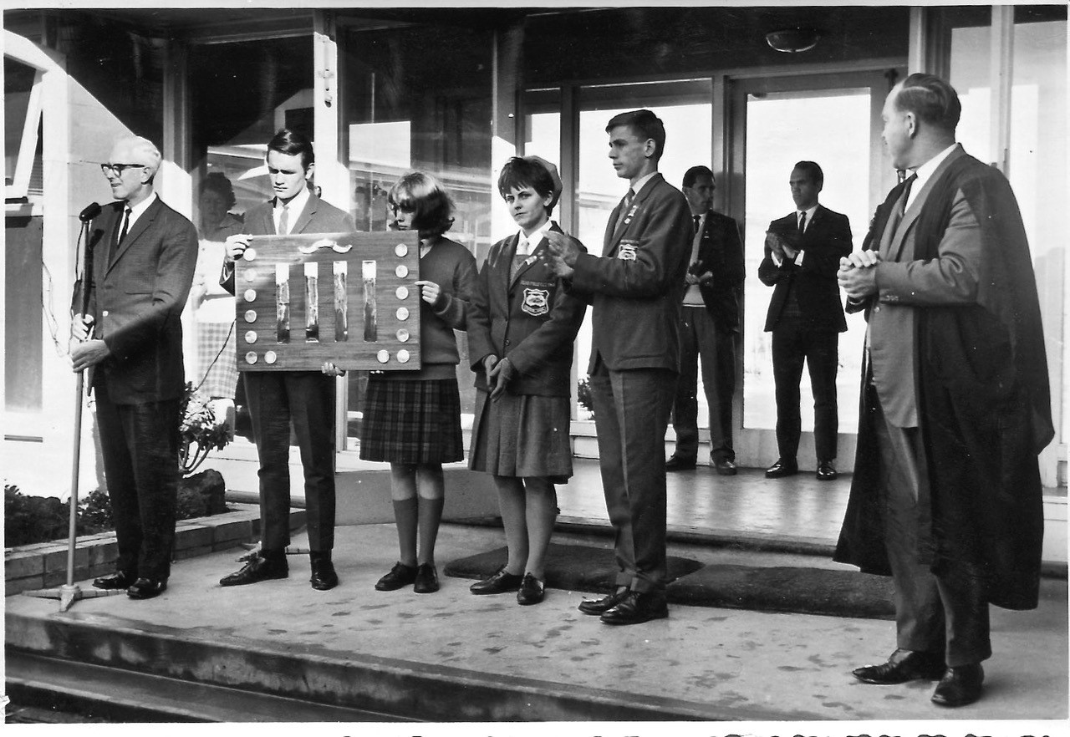
This photo was taken in 1965 at the opening ceremony for the first ever Exchange between our schools. On the left is our first Exchange principal Mr Valentine Aubrey Hamilton Prider. In the middle are the college head prefects of the time holding the Shield we still compete for today. At the back are the two Sports masters Tom Edge and Ross Smith, and on the far right is Cheltenham’s Principal of the time Mr Fowler.
The Exchange began when two PE teachers, Mr Jeff Nicholas from the then Gilles Plains HS and Mr Ross Smith from Cheltenham High School collaborated to create an Exchange that provided opportunities for students to compete in a variety of sporting and cultural events. They hoped students would develop attributes such as sportsmanship, teamwork, resilience and respect.
Early Exchange events included boy’s football, girl’s netball, chess, debate, cross country running and boys’ soccer. Through the years our students have also competed in swimming, baseball, softball, squash, athletics and even golf.

Whilst many of the sports may have changed the original aims of the Exchange remain the same. We encourage students to compete hard but also to show sportsmanship and respect regardless of the result.

The Exchange Commitment:
“I have my honour and reputation, and those of my school, at stake and I will behave as befits these commitments.
I will show respect, courtesy and consideration to my hosts and the students and staff from both schools.
I will compete in my events as well as I am able, in the best sporting interest – and I will be gracious in victory and defeat.”

